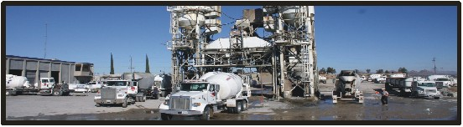
D
$1,500 DRIVER
SIGN-ON BONUS
What would you do with more cash?
_____
Sign-on Bonus Program worth $ 1,500
_____
Benefits:
Medical, dental, vision, life ins & AFLAC after 30 days of employment.

Additional Benefits:
PTO, holiday pay & 401K with Employer contribution.

What a great program!

Here’s how it works:

Hi-Grade Materials will pay out:
- $ 1,500 after 90 days of employment

Apply on site or online @ www.Robar.com

Must have:
- Commercial Driver’s License (Class A or B),
- 6 months commercial driving experience
- Tank Endorsements
- Doubles preferred

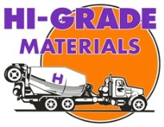
Valid For:
23382 National Trails Hwy Oro Grande
38050 Monroe St. Indio

Offer expires May 31, 2018

